**Week 63 From March 12.2022 to March 18.2022**

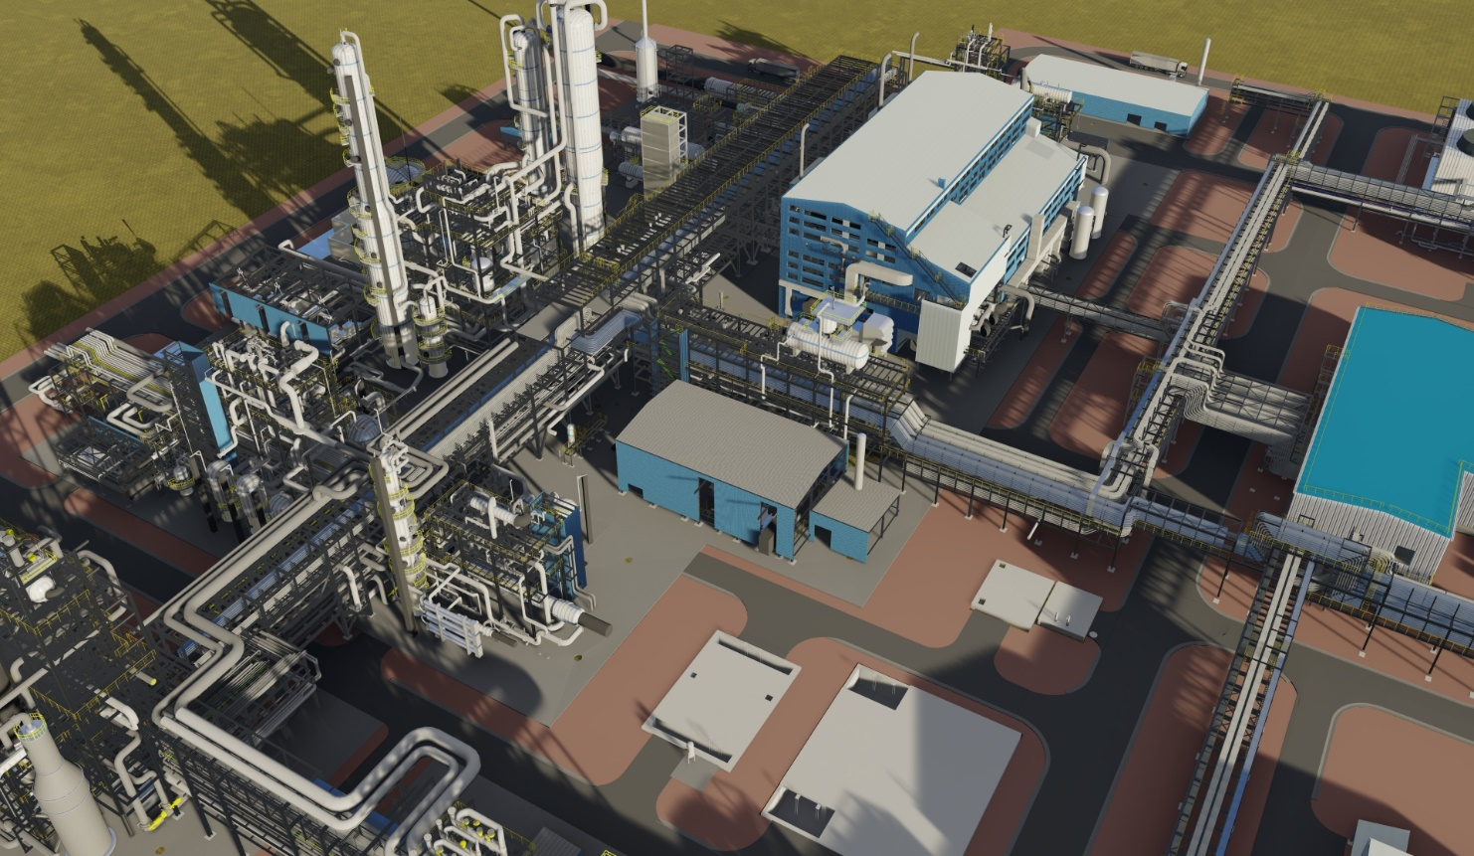

**TABLE OF CONTENTS**

A) JOB IDENTIFICATION 3

A.1) GENERAL DATA 3

A.2) CONTRACTUAL MILESTONES 3

A.3) MAJOR ACHIEVEMENTS DURING THIS WEEK 4

A.4) MAJOR ACHIEVEMENTS PLANNED FOR NEXT WEEK 5

A.5) TOP CRITICALITIES, AREAS OF CONCERN 6

B) THREE WEEKS LOOKHED PROGRESS 12

C) HSE FIGURES 13

D) CONSTRUCTION SUMMARY 14

E) CONSTRUCTION DETAILS 15

E.1) CONSTRUCTION EQUIPMENT AT SITE 15

E.2) PROGRESS ‘S’ CURVES 16

F) SITE ORGANIZATION CHART 28

G) GENERAL PLOT PLANS 29

H) PHOTOGRAPHIC REPORT 35

# JOB IDENTIFICATION

## A.1) GENERAL DATA

|  |  |
| --- | --- |
| **JOB NUMBER** | **4124** |
| **PLANT** | Ammonia and Urea Production Plant |
| **CAPACITY** | 3000 MTPD Ammonia and 4000 MTPD Urea and Granulation Project |
| **LOCATION** | Industrial Area “Phosphorit”, Kingisepp District, Leningrad Region |
| **COUNTRY** | Russian Federation |
| **OWNER** | LLC “EUROCHEM NORTHWEST-2” |
| **SITE MANAGER** | Marko Vidovic |

|  |  |
| --- | --- |
| **Milestone Description** | **Baseline Date** |
| CONTRACT AWARD | N\A |
| PROJECT START (NOTICE TO PROCEED | 01-Apr-2021 |
|  |
| Civil Works | 16- Apr-2021 |
| Steel Structures | 2-Jul-2021 |
| Equipment Erection | 20-Nov-2021 |
| Electrical Works | 8-May-2022 |
| Instrumentation Works | 3-Jun-2022 |
| Painting Works | 1-Dec-2021 |
| LB Pipe Fabrication | 5-Oct-2021 |
| LB Piping Erection | 18-Feb-2022 |
| Cable Trays | 18-Feb-2022 |
| Insulation Works | 27-May-2022 |
|  |

## A.2) CONTRACTUAL MILESTONES

## A.3) MAJOR ACHIEVEMENTS DURING THIS WEEK

|  |  |
| --- | --- |
| Civil Works | 43 m3 Ammonia of foundation concrete works  284m3 Urea of foundation concrete works  **Cumulative Ammonia – 3134 m3**  **Cumulative Urea - 20398m3**  **Cumulative Total - 23533m3** |
| Steel Structures erection | Ammonia – 42 tons; Urea – 47 tons  **Cumulative Ammonia - 1,951 t**  **Cumulative Urea - 1196 t**  **Cumulative Total - 3147 t** |
| UG Pipe Fab & Erect | Ammonia – 847 DI; Urea – 404 DI  **Cumulative Ammonia - 24272 DI**  **Cumulative Urea - 10952 DI**  **Cumulative Total - 35224 DI** |
| Piping Prefabrication; A/G(LB) | Ammonia – 2366 DI; Urea – 1636 DI  **Cumulative Ammonia – 47636 DI**  **Cumulative Urea - 27120 DI**  **Cumulative Total – 74756 DI** |
| Pits installation | Urea – 27 m3  **Cumulative: 432 m3** |
| UG Gravity Lines | 211 m  **Cumulative: 4003 m** |
| Equipment | Ammonia – 107 t; Urea – 25 t  **Cumulative Ammonia – 339 t**  **Cumulative Urea – 73 t**  **Cumulative Total – 413 t** |
| Painting | Ammonia – 539 m2; Urea – 204 m2  **Cumulative Ammonia – 6797 m2**  **Cumulative Urea - 5090 m2**  **Cumulative Total - 11887 m2** |
| Cable Trays | Ammonia – 0 m; Urea – 492 m  **Cumulative Ammonia – 390 m**  **Cumulative Urea - 1596 m**  **Cumulative: 1986 m** |
| LB Piping Erection | Ammonia – 0 DI; Urea – 4 DI  **Cumulative Ammonia – 0 DI**  **Cumulative Urea - 81 DI**  **Cumulative Total - 81 DI** |

## A.4) MAJOR ACHIEVEMENTS PLANNED FOR NEXT WEEK

|  |  |
| --- | --- |
| Civil Works | 231 m3 Ammonia of foundation concrete works  462 m3 Urea of foundation concrete works  **Total per week – 693m3** |
| Steel Structures | Ammonia - 274 tons;  Urea - 134 tons  **Total per week - 408 t** |
| UG Pipe Fab & Erect | Ammonia – 646 DI; Urea – 372 DI  **Total per week - 1018 DI** |
| Piping Prefabrication; A/G(LB) | Ammonia – 5917 DI; Urea – 1993 DI  **Total per week - 7909 DI** |
| Pits installation | Urea – 11 m2 |
| UG Gravity Lines | Urea – 227 m |
| Equipment | Ammonia – 241 t; Urea – 218 t  **Total per week – 459 t** |
| Painting | Ammonia – 1920 m2; Urea – 609 m2  **Total per week - 2529 m2** |
| Cable Trays | Ammonia – 596 m; Urea – 867 m  **Total per week – 1462 m** |
| LB Piping Erection | Ammonia – 884 DI; Urea – 226 DI  **Total per week - 1110 DI** |
| Pipe Support | Ammonia – 3021 kg; Urea – 798 kg  **Total per week - 3818 DI** |

## A.5) TOP CRITICALITIES, AREAS OF CONCERN

|  |  |
| --- | --- |
| 1 | **Delay on Steel Structure Delivery.**  Generally there’s been some continuous issues with delivery of steel structure elements. |
| 2 | **Poor scope of erectable Steel in the warehouse.**  Also some of the steel is not erect due to the lack of key parts such are bolts, and even columns. In other words if significant amount of steel is on site, doesn’t mean that we necessarily have an open front.  One of the reasons is not having concrete work done, which naturally stopping steel works. |
| 3 | **Delay Equipment Delivery.**  In the lights of the current situation, most of deliveries are delayed. For example the Load No 167, from supplier “SEONGHWA”, was scheduled to be delivered on 1st March of 2022 (equipment delivery forecast from 28.02.2022.), and latter on is set to come on March 7th (equipment delivery forecast from 07.03.2022.)  Also if we look the same delivery forecast lists we can see that Load No 173 (Supplier “NOOTER ERIKSEN”) is first scheduled to come on March 20th, and latter on is prolonged on March 25th.  Based on this data we can expect to have similar issues in the future also. |
| 4 | **Delay on Area by handover ESTA.** |
| 5 | **Delay on anchor bolt Delivery.**  Some problems with delivery of the anchor bolts affected concrete works on foundations and later on erection of steel structure. As of today we can say that we solved this problem by delivering the big major part of necessary items. |

Table 5.1 General comments

More precise information about each structure, and reasons of delay, in terms of unused material from the warehouse, are given in following tables. Data are filtered by site, when it’s about structures that are part of “Velesstroy-SMU” scope, while for “Lenmontage” available information are presented in one table.

Equipment is presented by delivery months.

Structures that are not presented are either on very low percentage of delivered steel or there is no steel delivered at all.



Table 5.2: Steel Structure – Amount of not erected material available in warehouse, Ammonia

Velesstroy-SMU





Table 5.3: Steel Structure – Amount of not erected material available in warehouse, Urea

Velesstroy-SMU





Table 5.4: Steel Structure – General comments, Ammonia & Urea

Lenmontage



Table 5.5: Equipment – data for January



Table 5.6: Equipment – data for February



Table 5.7: Equipment – data for March



Table 5.7: Equipment – Additional data for March

# THREE WEEKS LOOKAHEAD PROGRESS

|  |  |  |  |  |
| --- | --- | --- | --- | --- |
| **THREE WEEKS LOOKAHEAD PROGRESS** | | | | |
| **Earth Works** | **UNIT** | **64.Week**  **25.03.2022** | **65.Week**  **01.04.2022** | **66.Week**  **08.04.2022** |
| Concrete Works | m3 | 693 | 698 | 593 |
| Pits | m3 | 11 | 15 | 26 |
| UG Gravity Lines | m | 227 | 229 | 372 |
| Steel structures | t | 408 | 434 | 389 |
| UG Pipe Fab & Erect | Di | 1018 | 1237 | 985 |
| Piping Prefabrication A/G(LB) | Di | 7909 | 7607 | 7564 |
| Equipment | t | 459 | 633 | 656 |
| Painting | m2 | 2529 | 2449 | 2411 |
| Cable Trays | m | 1462 | 2426 | 2592 |
| LB Piping Erection | Di | 1110 | 1065 | 938 |
| Pipe Support | kg | 3818 | 3824 | 9036 |

# HSE FIGURES

|  |  |
| --- | --- |
| **HSE STATISTICS** | **TOTAL** |
| **Total Man Hours (This Week)** | **142 240** |
| **Total Man Hours (Cumulative)** | **2 988 415** |
| Daily Manpower Total (Average) | 2033 |
| STAFF & IND (AVG) / DIRECT (AVG)/ DIRECT TCF (AVG) | **749/766/241** |

# CONSTRUCTION SUMMARY

C3 Progress Urea Civil.



C3 Progress Ammonia Civil.



# CONSTRUCTION DETAILS

## E.1) CONSTRUCTION EQUIPMENT AT SITE



## E.2) PROGRESS ‘S’ CURVES

**Overall Progress & Mobilization Plan S Curve**

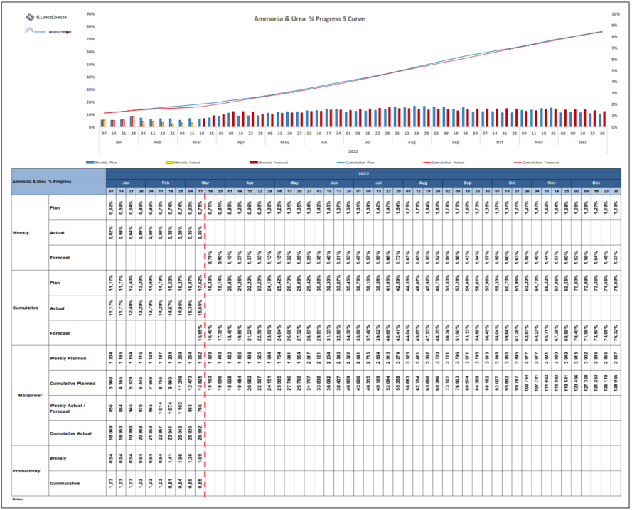

**Concrete Works S Curve**

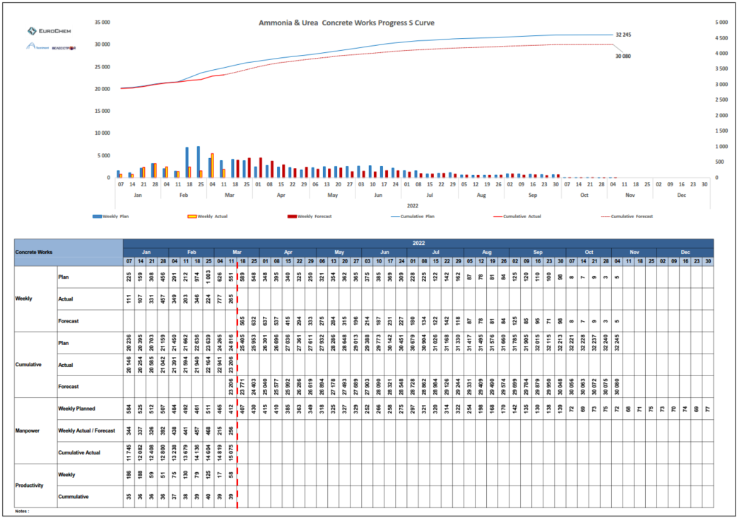

**Steel Structure Erection Works Progress S Curve**

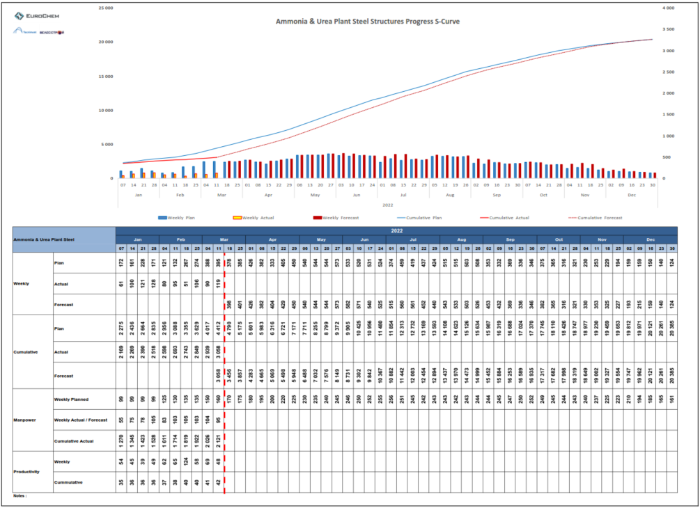

**UG Pits Works S Curve**

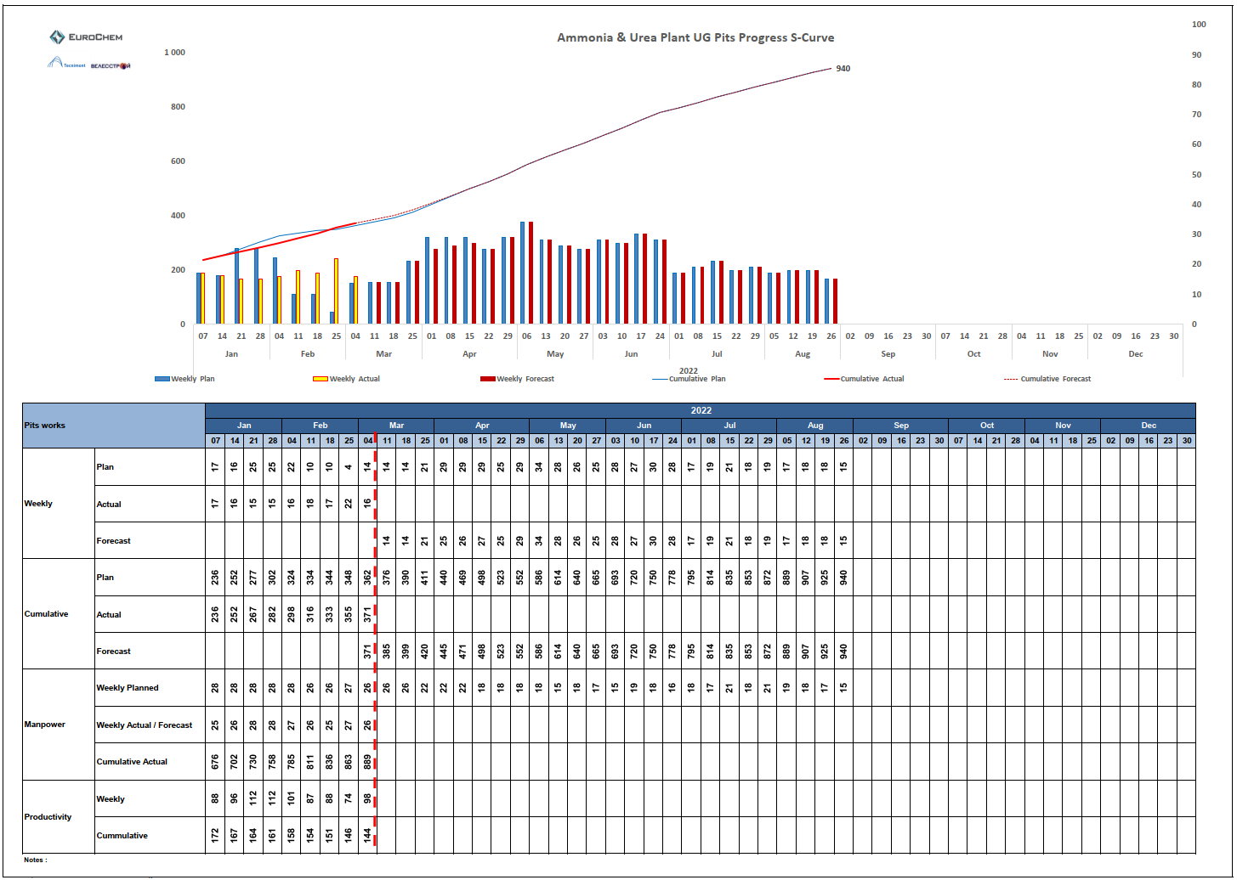

**UG Gravity Lines S Curve**

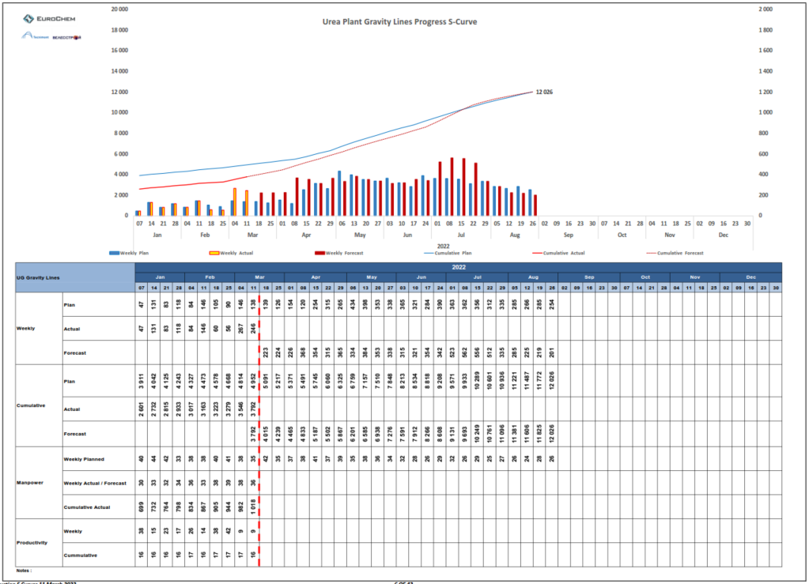

**UGP (Fab & Erect) S Curve**

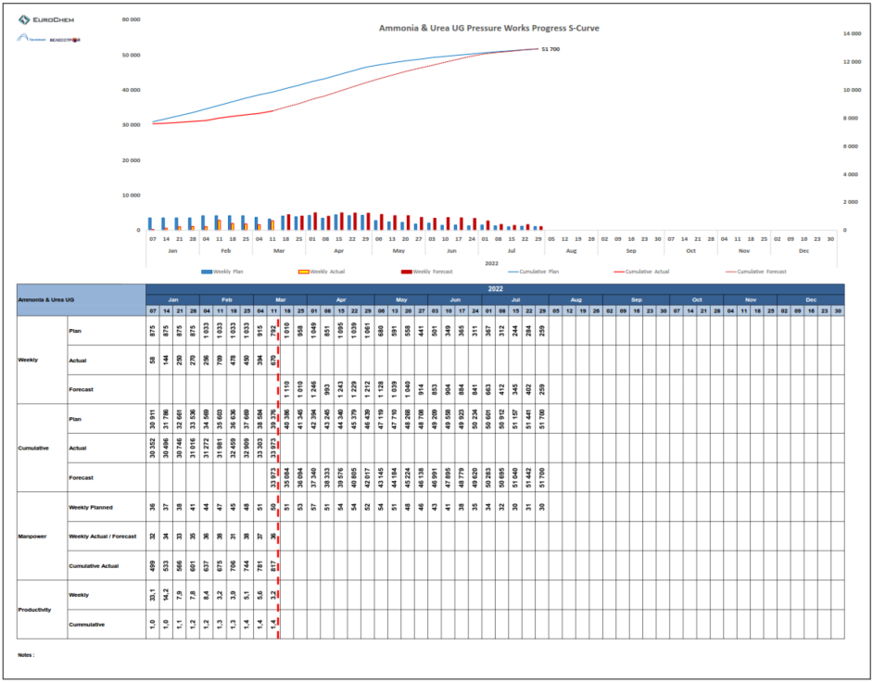

**LB Piping Fabrication S Curve**

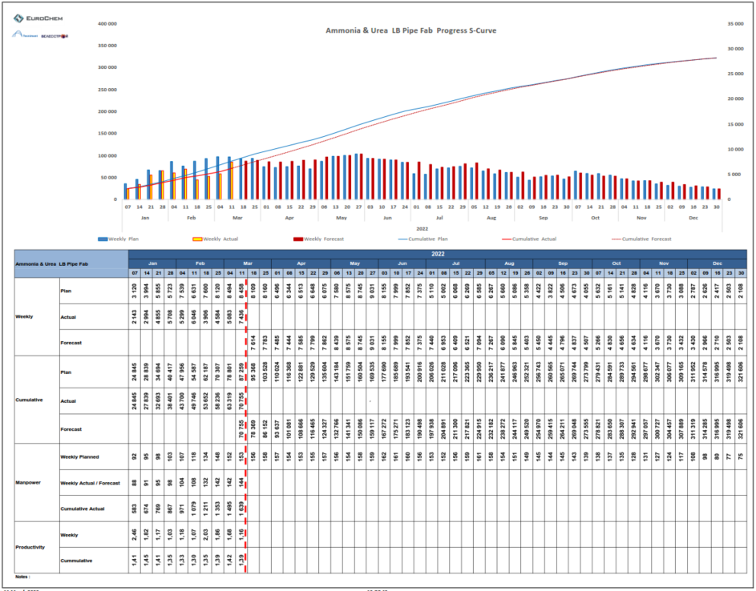

**LB Piping Erection S Curve**

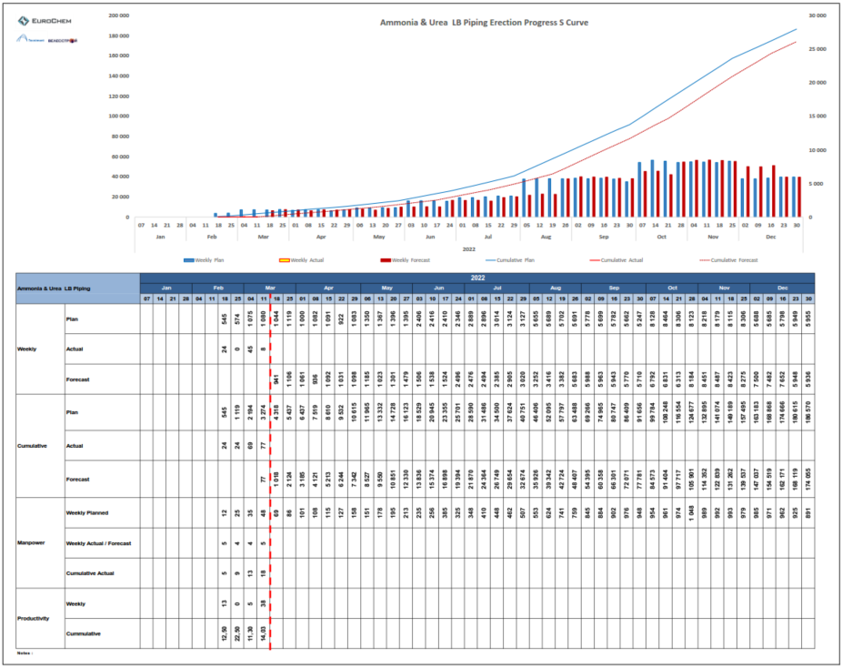

**Pipe Supports Erection S Curve**

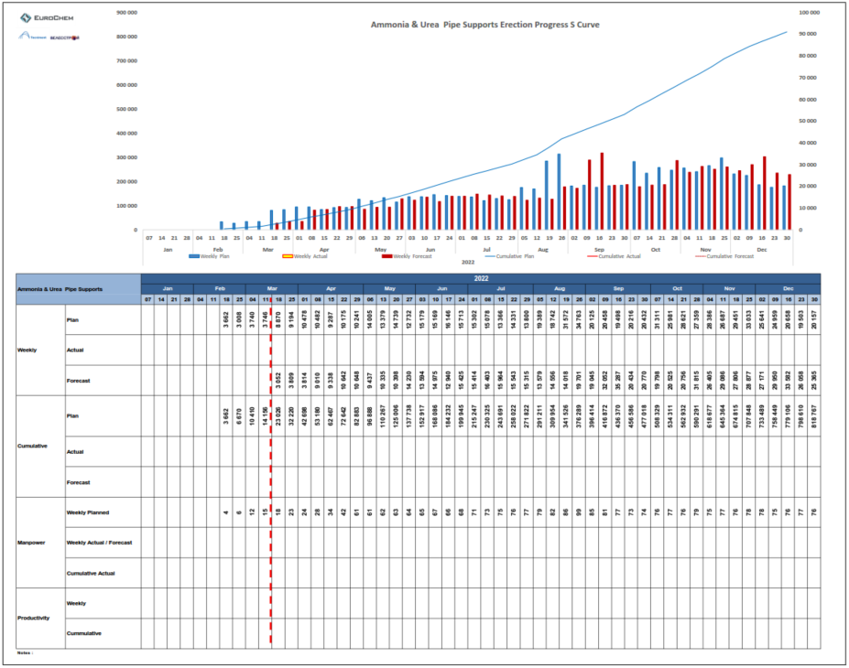

**Equipment** **S Curve**

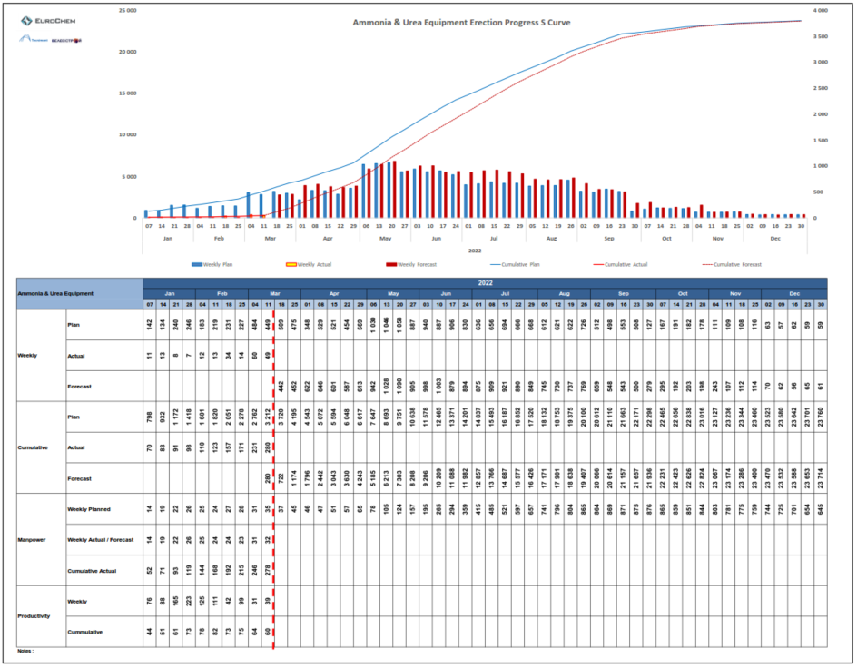

**Cable Trays** **S Curve**

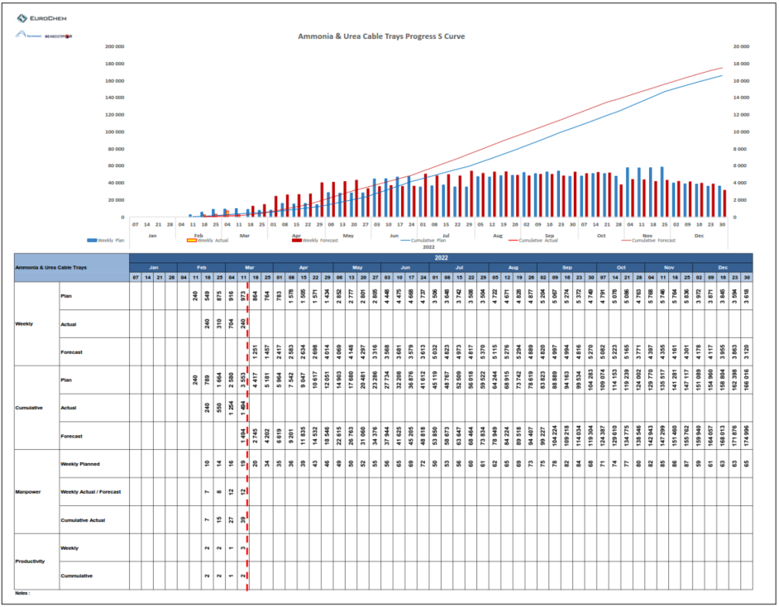

**Painting S Curve**

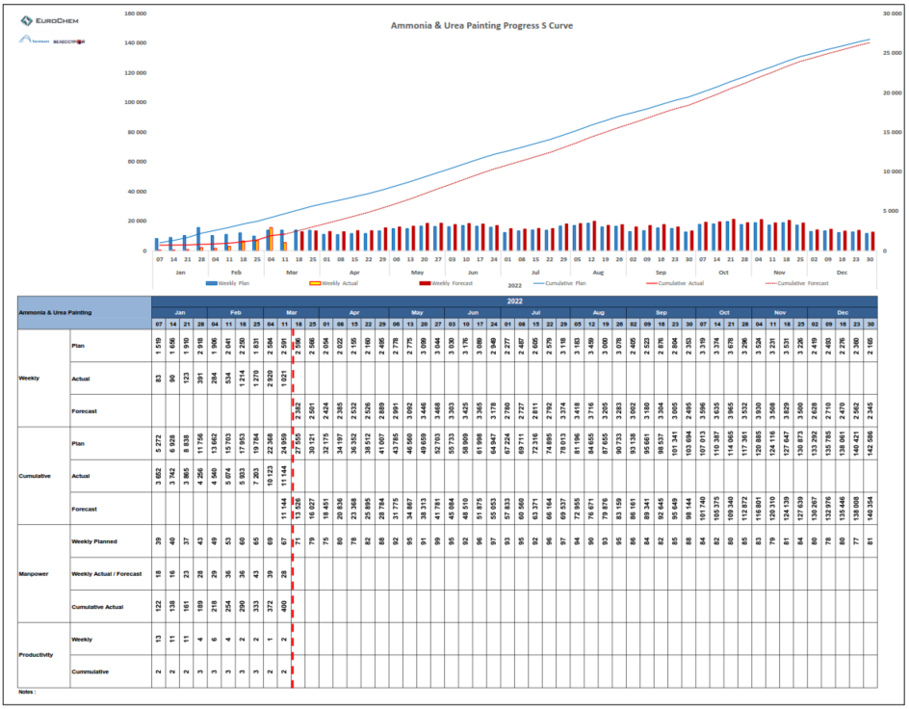

# SITE ORGANIZATION CHART

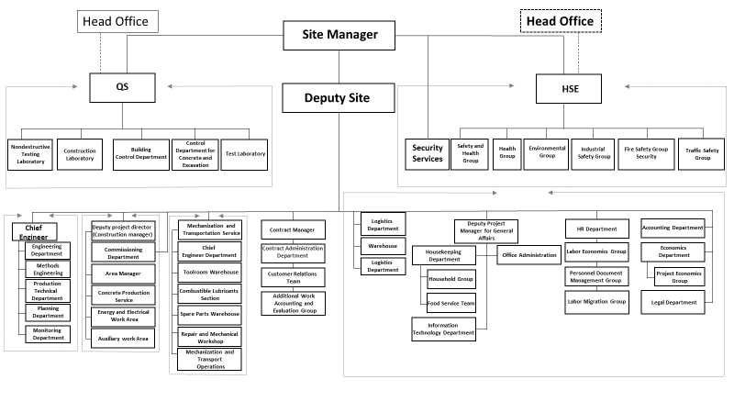

# GENERAL PLOT PLANS

AMMONIA CONCRETE

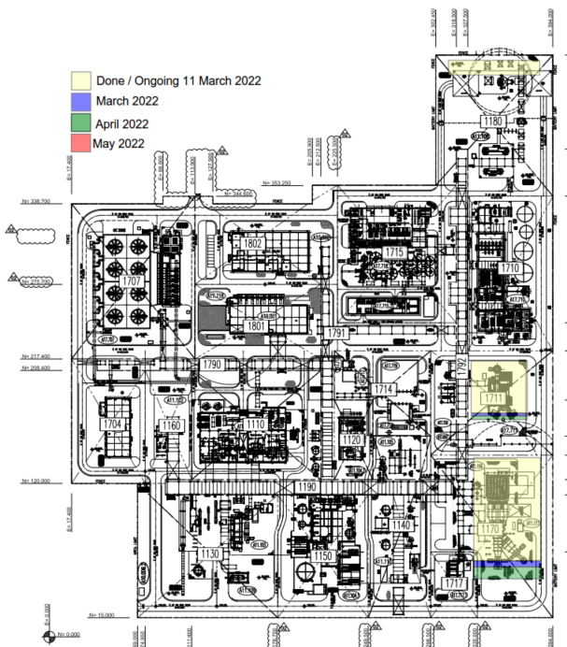

UREA CONCRETE

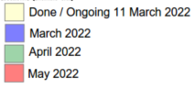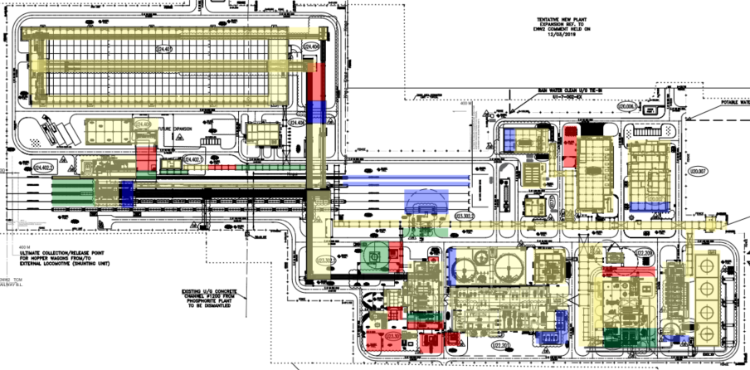

AMMONIA STEEL

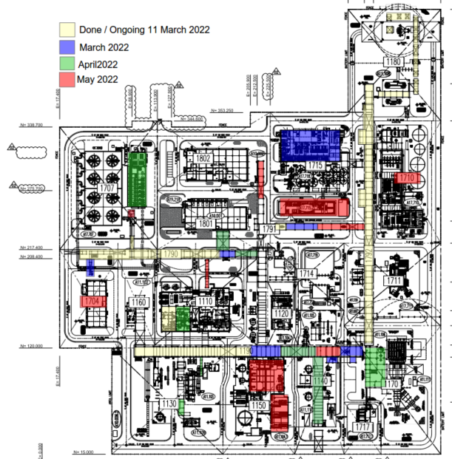

UREA STEEL

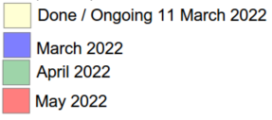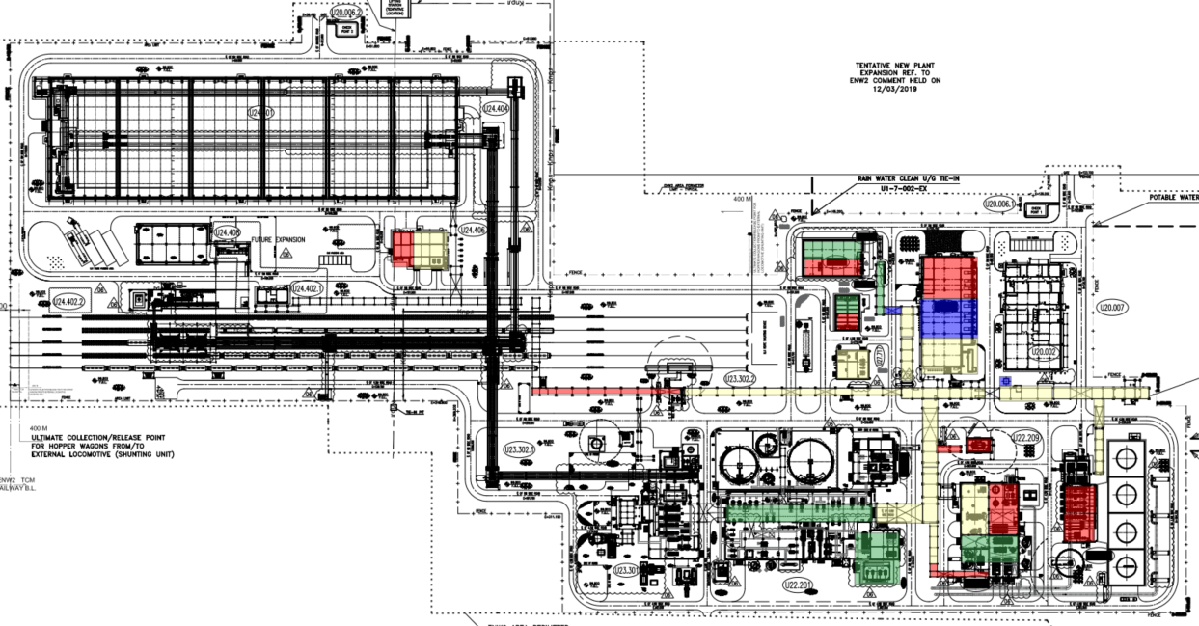

AMMONIA UNDERGROUND INSTALLATIONS (COOLING WATER)

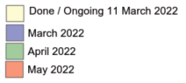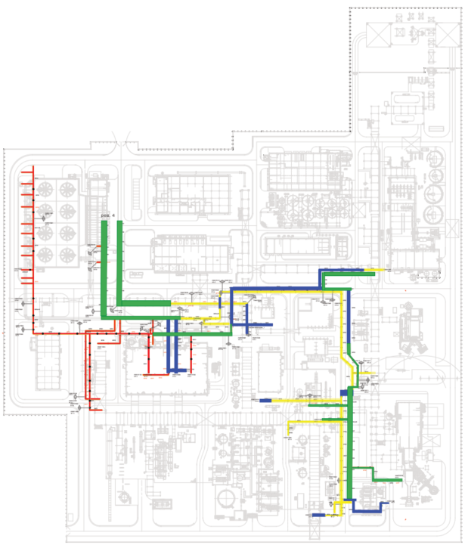

UREA UNDERGROUND INSTALLATIONS (COOLING WATER)

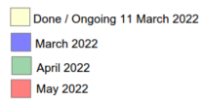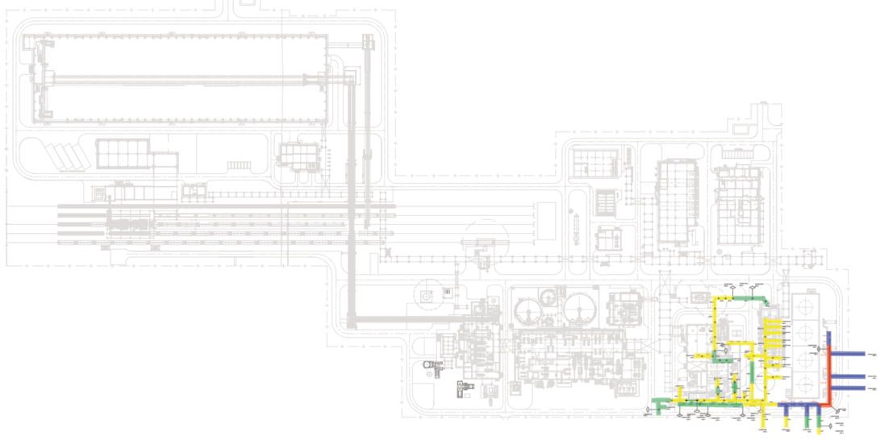

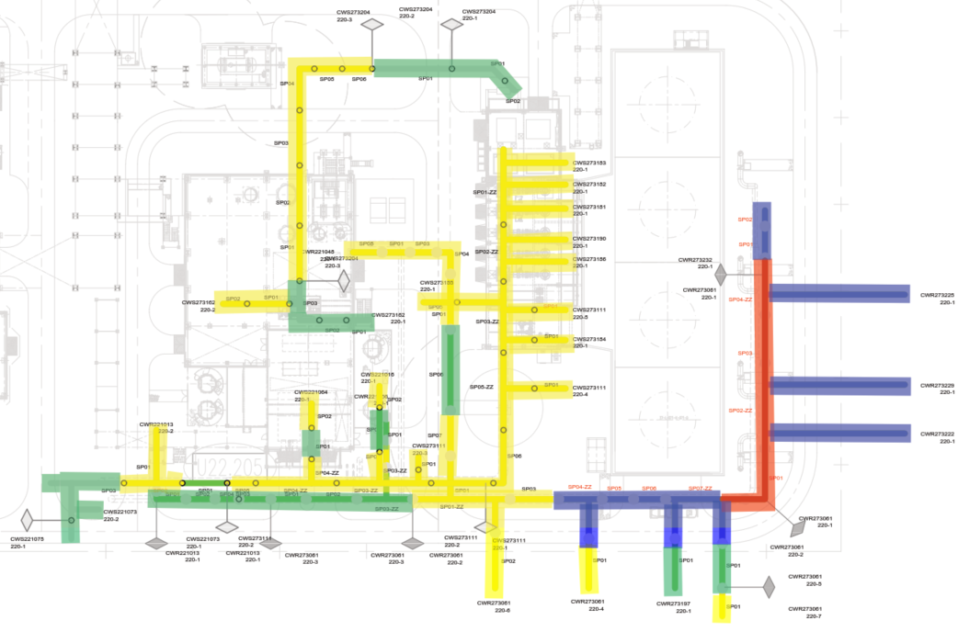

# PHOTOGRAPHIC REPORT

AMMONIA

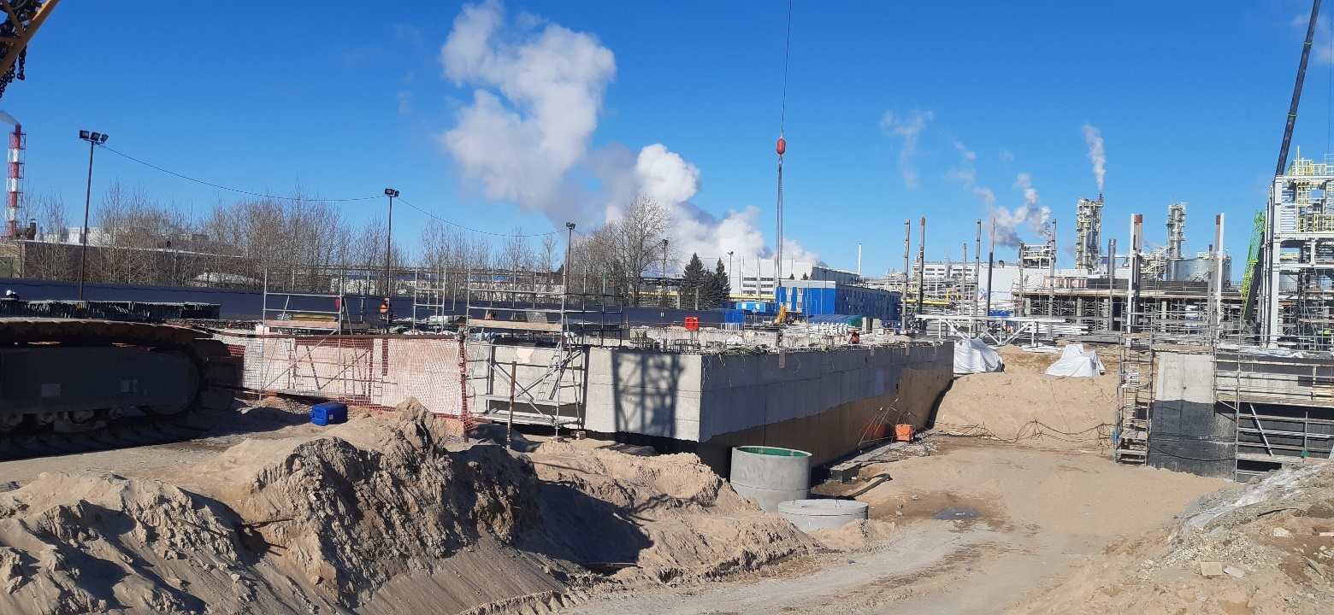

2714 Urea Utilities Area

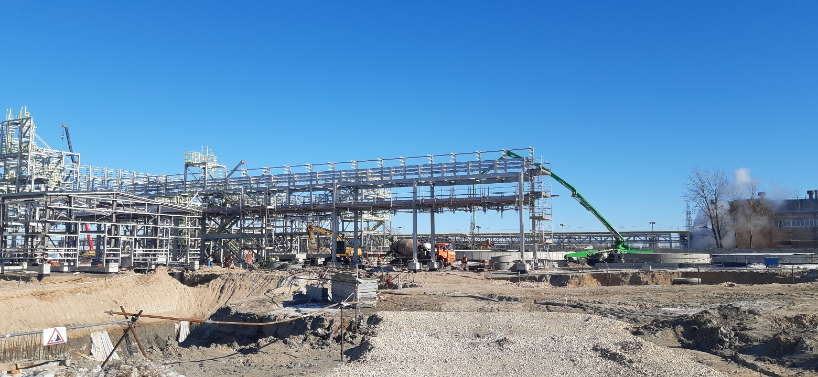

2790 Utility Pipe Rack Area

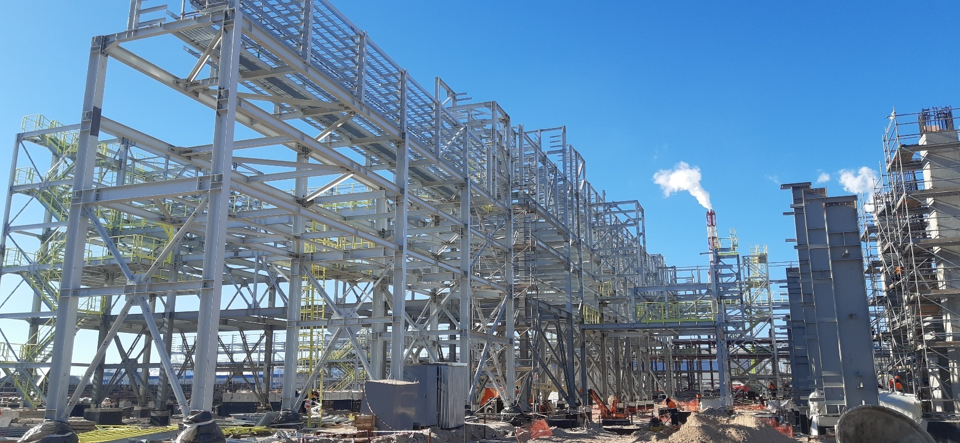

2290 Urea Melt Process Pipe Rack Area

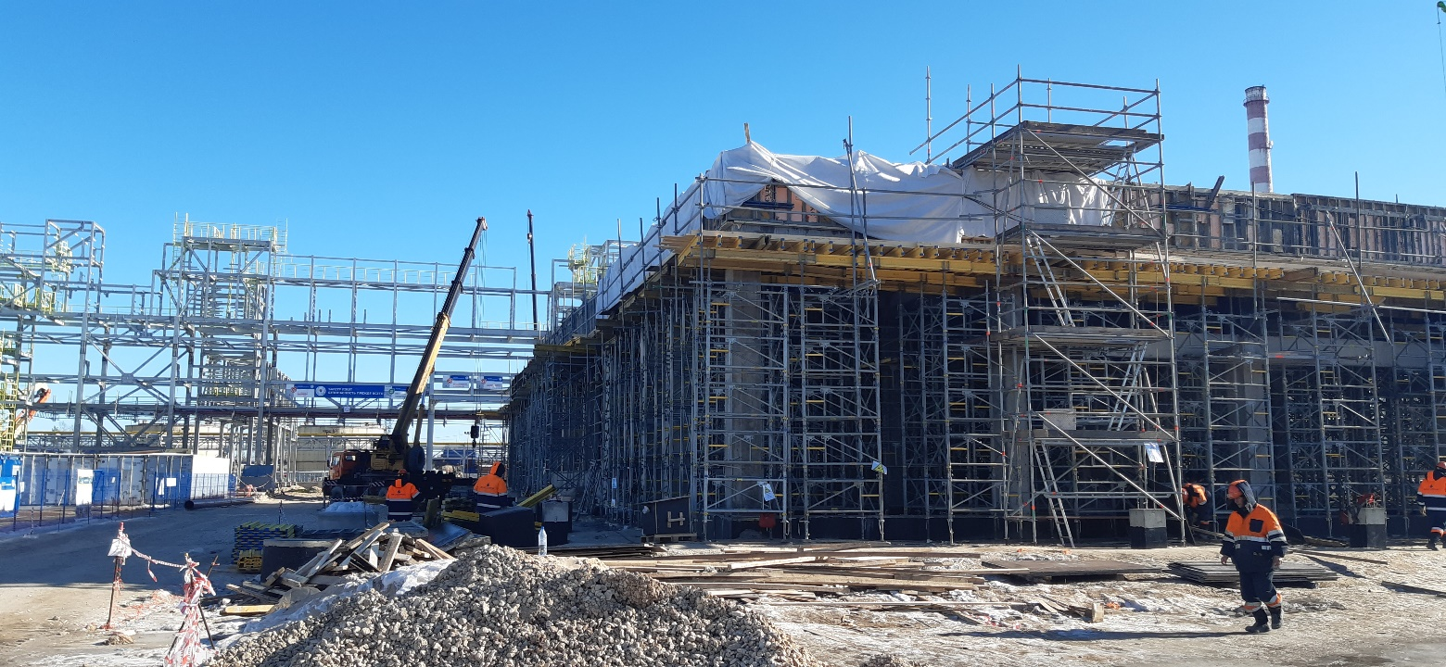

2802 Urea Control Room Area

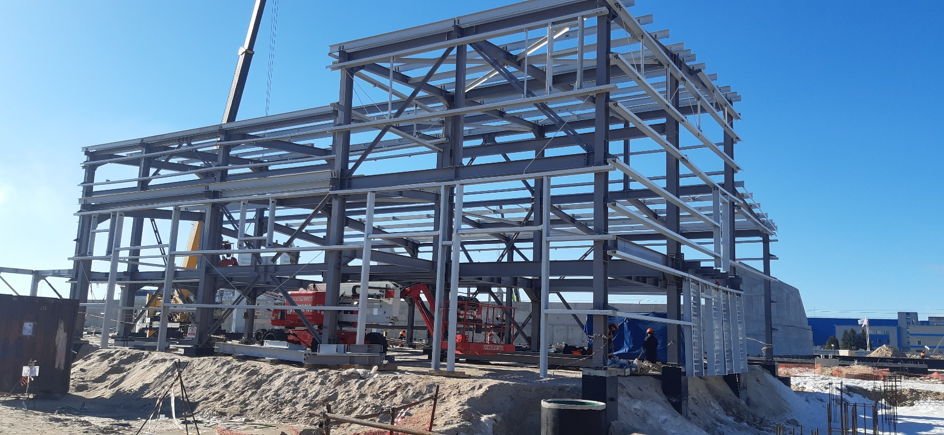

2406 Secondary Electrical SS & Rack Room

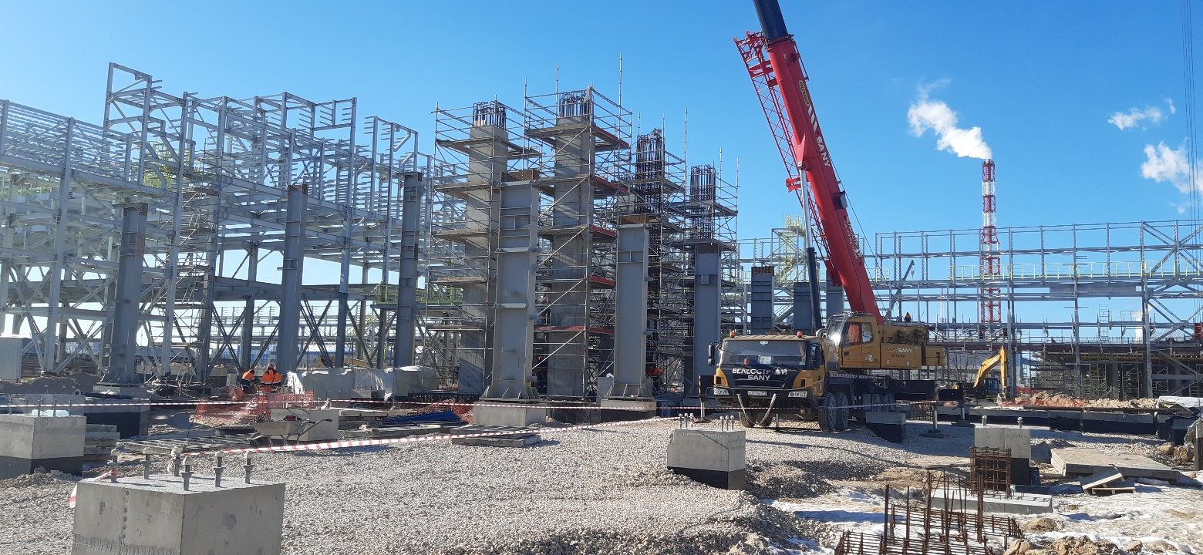

2205 Urea Melt Compressors Area

UREA

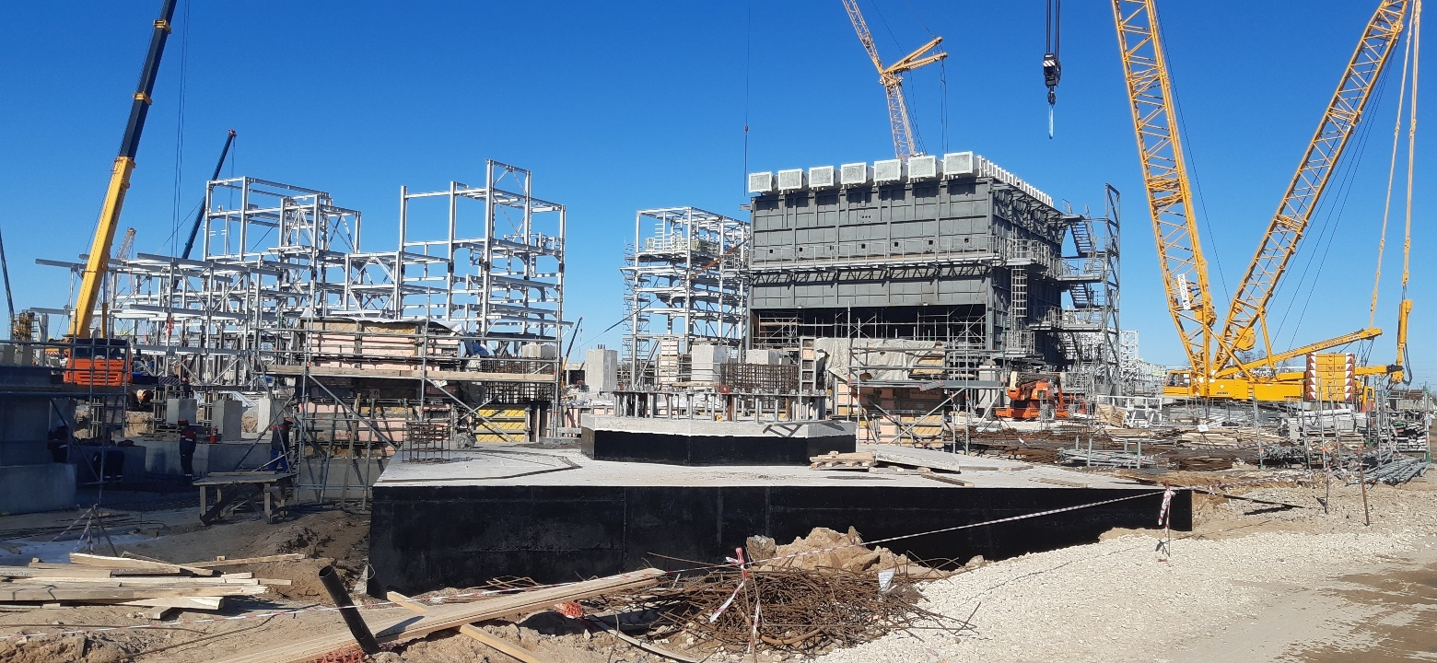

1170 Primary Reformer Area

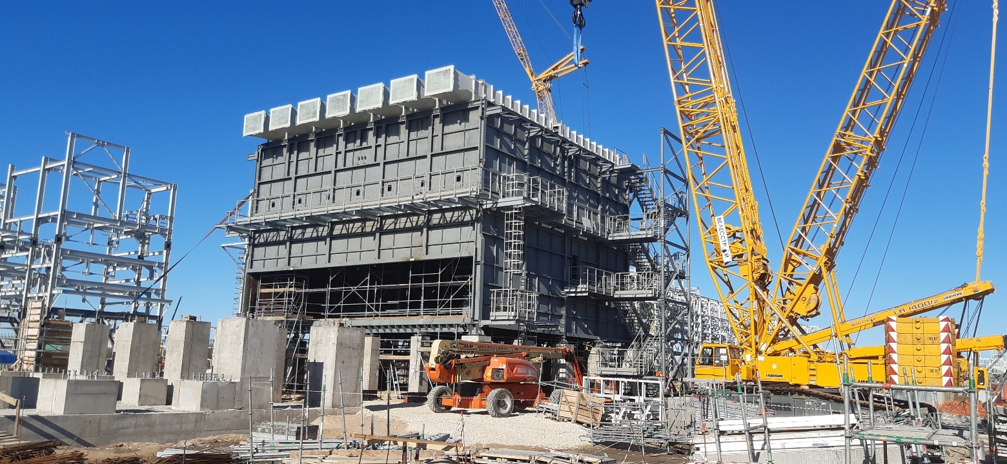

1170 Primary Reformer Area

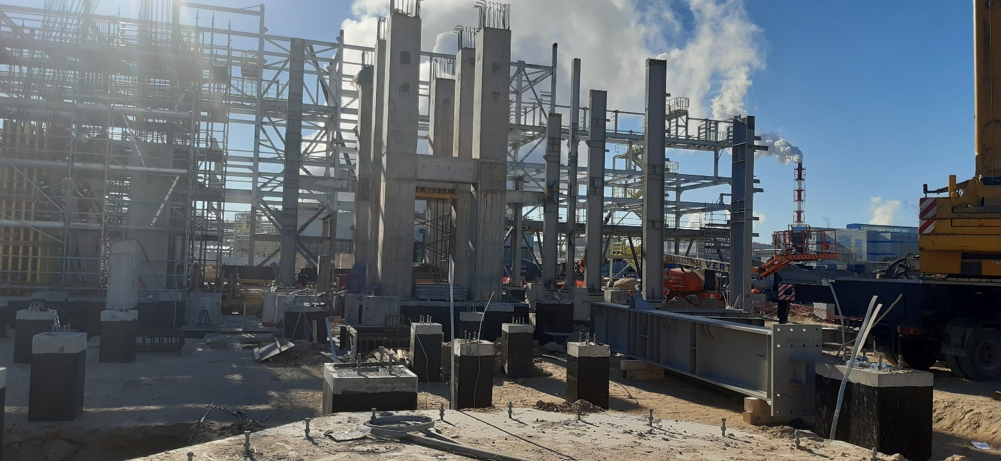

1110 Flare area

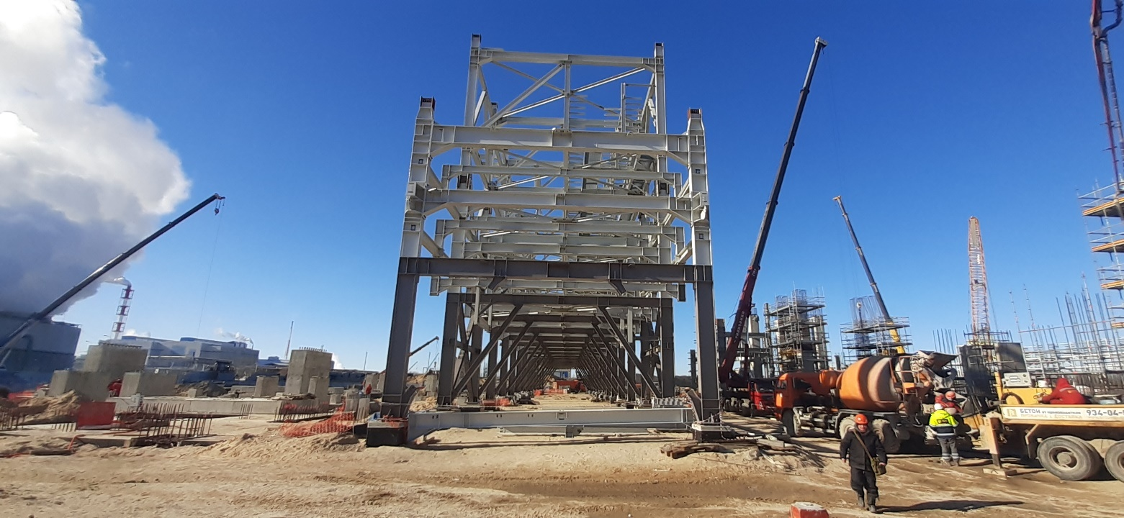

1190 Ammonia Process Piperack

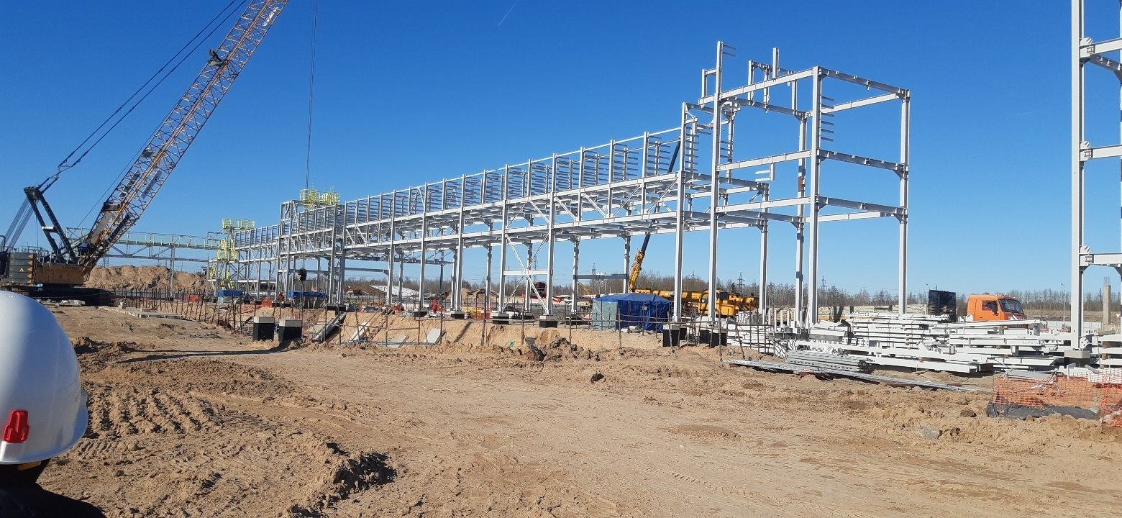

1790 Ammonia Utility Piperack

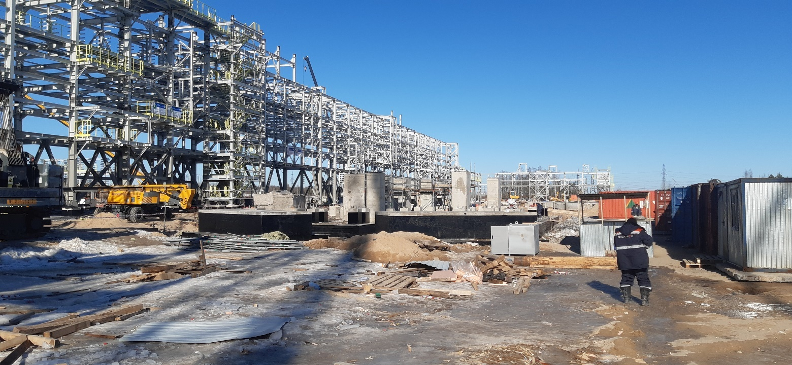

1711 Auxiliary Boiler Area